Connection Manual
Advantage 400

Delta Tau Europa AG

Delta Tau Europa AG, Gewerbestrasse 8, CH-8212 Neuhausen, Tel. 0041/526252088, Fax: 0041/526254482,
dteuropa@deltatau.com
www.deltatau.com

Mechanical Dimensions “new” enclosure
View 2-11: Enclosure Diagram for unit of 2004 and later | 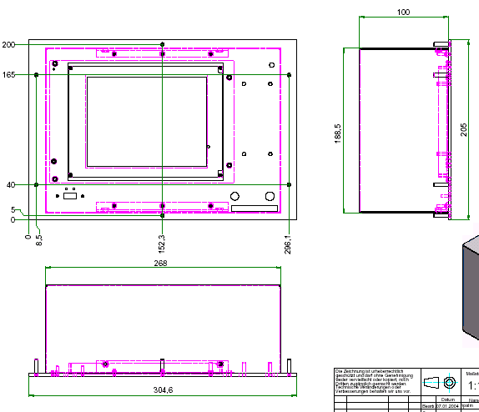

For fixation, these are 6x threaded stud M4 x 20 mm

Signal interfaces
All signal interfaces are found on the rear side of the control box.
Ports for the machine peripheral are female or male D-Sub connectors.
Exceptions are the IDC header for the optional MUX port (XX+)

View 2-2 Position and name of the connectors on the control boxes rear side

Encoder connectors (ENC n)
On the backside of the control box there are connectors for 6 incremental encoders.
For encoders n (n=1-6) of the axis 1-6 there’s the following specification:
Connector type: see View 2 -4
Position of connector: see View 2 –5 and View 2 -6

Name of connector:
View 2-3: Name of encoder connectors
  Female connector | Axis | Connector
  ENC 1 | X | D-SUB15 Female
  ENC 2 | Y | D-SUB15 Female
  ENC 3 | Z | D-SUB15 Female
  ENC 4 | U / A / S | D-SUB15 Female
  ENC 5/Hand Wheel | V/ B / HW | D-SUB15 Female
  ENC6 | free | D-SUB9 Female

Cable cross section:
- Signal lines>=0.14mm2
- Supply lines>=0.5mm2
Pin out of connector ENC n (n=1-5):
View 2-4 Pin out of connector ENC1-ENC5
  Enc n
  Pin# | Symbol | Function | Description
  1 | CHA1+ | Input | Pos. A Chan.
  2 | GND | Common | Digital Reference
  3 | CHB1- | Input | Neg. B Chan.
  4 | CHC1+ | Input | Pos. C Chan.
  5 | A+5V | Output | Digital Supply
  6 | NC
  7 | NC
  8 | NC
  9 | CHA1- | Input | Neg. A Chan.
  10 | CHB1+ | Input | Pos. B Chan.
  11 | GND | Common | Digital Reference
  12 | CHC1- | Input | Neg. C Chan.
  13 | NC
  14 | A+5V | Output | Digital Supply
  15 | NC

Pin out of connector ENC6:
View 2-5 Pin out of connector ENC6
  Enc 6
  Pin# | Symbol | Function | Description
  1 | GND | Common | Digital Reference
  2 | CHA6+ | Input | Pos. A Chan.
  3 | CHA6- | Input | Neg. A Chan.
  4 | CHB6+ | Input | Pos. B Chan.
  5 | CHB6- | Input | Neg. B Chan.
  6 | A+5V | Output | Digital Supply
  7 | CHC6+ | Input | Pos. C Chan.
  8 | CHC6- | Input | Neg. C Chan.
  9 | NC |  | .

Any signal type (e.g. A, A/) on the control box side is connected to a differential line driver of the following type:
View 2-6: Encoder input driver | 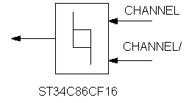
Supported encoder types:
Incremental encoders with differentials A quad B and C Signals (RS422).
Encoder specification:
- Signal lines A, A/, B, B/, optional C, C/
- Max. Cycle output frequency 20MHz
- Current consumption <100mA
- Phase difference of A to B: 90 degree +/-30
Encoder power:
The control boxes supplies 5 VDC via the respective female ENC n connector.
The max. Current consumption of all consumers like the
- Encoders connected to ENC1, ENC2, ENC3, ENC4, ENC5/HW1and ENC6
- Pulse and direction drivers on STP1 and
- Multiplexed IO boards connected to XX1
Must NOT exceed 2A!

Encoder connecting cable:
Length:
The maximum cable length depends on the transmission frequency and the power consumption of the encoder:
View 2-7: Max. Cable length of the encoder cables
  Current consumption | Frequency | Max. Cable length
  <100mA | 1MHz | 10m
  <100mA | 2MHz | 5m

Only use shielded twisted pair signal lines, put shield on conductive part of connector


WARNING
ONLY CONNECT ENCODERS WHEN CONTROLLER IS POWERED DOWN.
+/- 10V drive interface (Amp1)
This interface is intended to connect 5 amplifiers with +/-10V command.
In order to use the amplifier enable lines, external 24V is needed.
- 5 differential/ single ended +/- 10V command output signals
- Analog ground used as reference for a single ended command signal only
- 5 amplifier enable lines
- 5 amplifier fault lines
Name of the connector: AMP1
Position of connector: See picture 2 -9
Connector type: female, D-Sub 25
Cable cross-section:
- Signal lines >=0.34mm2
- Power lines >=0.5mm2
Pin Out of AMP1:
View 2-8 Pin out of AMP1 connector
  AMP 1
  Pin# | Symbol | Function | Description
  1 | DAC1A+ | Output | Analog Out + X-Axis
  2 | DAC1A- | Output | Analog Out - X-Axis
  3 | DAC2A+ | Output | Analog Out + Y-Axis
  4 | DAC2A- | Output | Analog Out - Y-Axis
  5 | DAC3A+ | Output | Analog Out + Z-Axis
  6 | DAC3A- | Output | Analog Out - Z-Axis
  7 | DAC4A+ | Output | Analog Out + U / A / S
  8 | DAC4A- | Output | Analog Out - U / A / S
  9 | AGND | Output | Ref. for command (analog) out
  10 | AMP1-ENA | Output | Amplifier Enable X-Axis
  11 | AMP2-ENA | Output | Amplifier Enable Y-Axis
  12 | AMP3-ENA | Output | Amplifier Enable Z-Axis
  13 | AMP4-ENA | Output | Amplifier Enable U / A / S
  14 | AMP5-ENA | Output | Amplifier Enable U / A / S
  15 | AMP1-FLT | Input | Amplifier fault 1 X-Axis
  16 | AMP2-FLT | Input | Amplifier fault 2 Y-Axis
  17 | AMP3-FLT | Input | Amplifier fault 3 Z-Axis
  18 | AMP4-FLT | Input | Amplifier fault 4 U / A / S-Axis
  19 | AGND | Output | Ref. for command (analog) out
  20 | AMP5-FLT |  | Amplifier fault 5 V / B-Axis
  21 | DAC5A+ |  | Analog Out + V / B-Axis
  22 | DAC5A- |  | Analog Out - V / B-Axis
  23 | NC
  24 | Ext +24V | Input | External +24V
  25 | Ext GND | Input | External ground, "FIELDRETURN"
Amplifier enables:
The following block diagram shows the amp enable and its corresponding power supply:
View 2-9: Principle of amplifier enable | 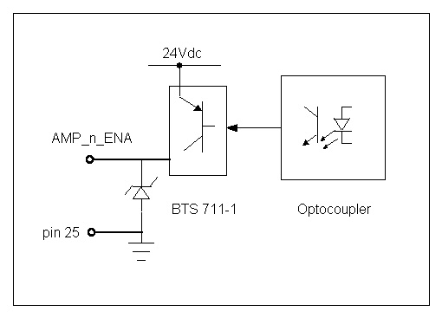
The specs of the amp enable lines is the following:
View 2-10 Electrical specs of the amp enable
  Parameter | Min | Max | Unit
  Voltage range | 12 | 24 | V
  Switching current |  | 0.5 | A

Amp fault Inputs:
The amp fault inputs are axis specific. The reference signal for them is on AMP1 Pin 25
View 2-12 shows the amp fault input block diagram:
View 2-11: block diagram of amplifier fault inputs | 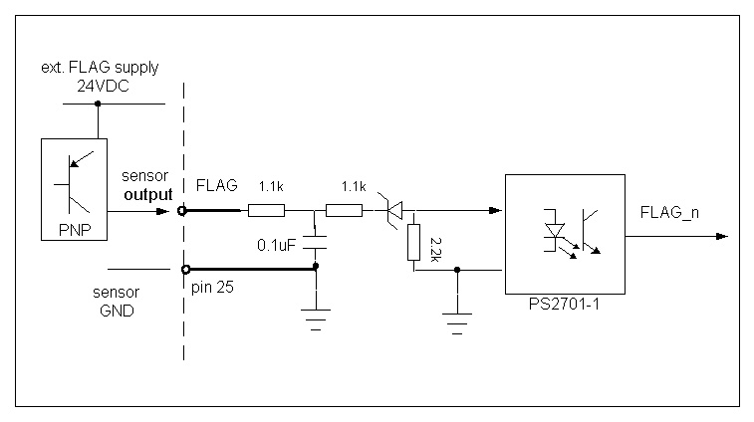

The electrical specs of the amp fault is the following:
View 2-12: electrical specs of the amp faults inputs
  1- Signal voltage range | 11-30 V
  1-Signal current consumption | 5-20mA
  0- Signal voltage range | 0-5 V or input not connected

Analog command outputs (+/-10V):
Singled ended command output connection
If the drive is single ended, connect only command output DAC+ to the input of the drive. Connect analog AGND (PIN 9) to the drives’ reference.
Differential command output connection
If the drive has a differential command input driver connect both, DAC+ und DAC-, to the input driver of the drive. Leave AGND floating.
View 2-13: Schematic of command output | 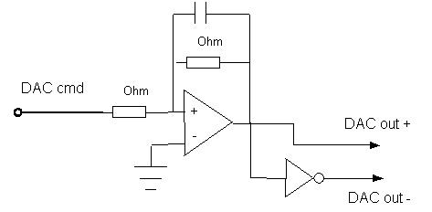
The following chart shows the specs of the command output signals:
View 2-14: Command output specs
  Parameter | Min | Max | Units
  Volage range | - 10 | 10 | V
  Output current | -3 | 3 | mA
  Resolution | 12 bit

Only use shielded twisted pair signal lines, put shield on conductive part of connector.

Flag connector (FLG1)
This male connector has all axis specific “FLAG” inputs for 5 axes. Each axis has the following set of inputs:
- Positive end limit (+LIM)
- Negative end limit (-LIM)
- User input (User)
- Home input (HOME)
Name of connector: FLAG1
Position of connector: See View 2 -16
Connector type: Male, D-Sub 25
Cable cross section:
- Signal lines >=0.34mm2
- Power lines>=0.5mm2
Pin out of FLG1:
View 2-15: Pin out of FLAG 1 connector
  FLG1
  Pin# | Symbol | Function | Description
  1 | USER1 | Input | General Capture Flag **
  2 | PLIM1 | Input | Positive Limit Flag **
  3 | MLIM1 | Input | Negative Limit Flag **
  4 | HOME1 | Input | Home Flag **
  5 | 24VDC out |  | Field power supply 24 VDC
  6 | USER2 | Input | General Capture Flag **
  7 | PLIM2 | Input | Positive Limit Flag **
  8 | MLIM2 | Input | Negative Limit Flag **
  9 | HOME2 | Input | Home Flag **
  10 | 24VDC out |  | Field power supply 24 VDC
  11 | USER3 | Input | General Capture Flag **
  12 | PLIM3 | Input | Positive Limit Flag **
  13 | MLIM3 | Input | Negative Limit Flag **
  14 | HOME3 | Input | Home Flag **
  15 | nc |  | Not connected
  16 | USER4 | Input | General Capture Flag **
  17 | PLIM4 | Input | Positive Limit Flag **
  18 | MLIM4 | Input | Negative Limit Flag **
  19 | HOME4 | Input | Home Flag **
  20 | GND out | Output | GND field power supply, flag ref
  21 | USER5 | Input | General Capture Flag **
  22 | PLIM5 | Input | Positive Limit Flag **
  23 | MLIM5 | Input | Negative Limit Flag **
  24 | HOME5 | Input | Home Flag **
  25 | GND out | Output | GND field power supply, flag ref
There are 2 24VDC outputs on FLG1 to supply potential sensors. Those 24 VDC lines are put through from the external field power supply.
View 2-16 Block diagram of flag inputs | 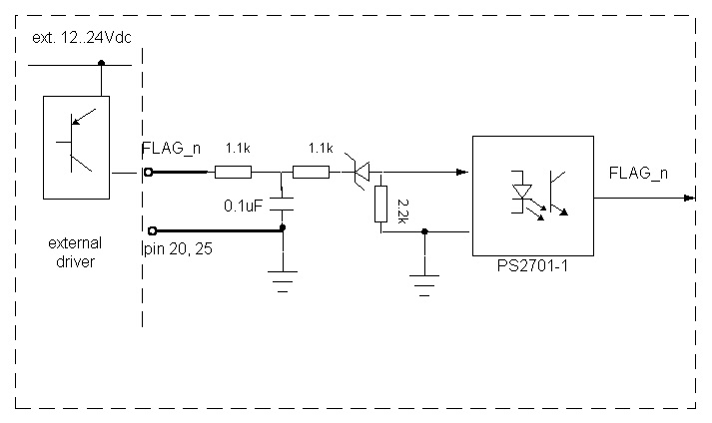

The electrical specs of the flag inputs shows the following chart:
View 2-17: 18 Electrical specs of flag inputs
  1- Signal voltage range | 11-30 V
  1-Signal current range | 5-20mA
  0- Signal voltage range | 0-5 V or input not connected

Stepper connector (STP1)
This connector is used to connect up to 4 stepper drives with pulse- and direction interface. Furthermore this connector has the 4 axis specific amp fault inputs.
Per stepper axis you have the following signals:
- 1 differential pulse signal
- 1 differential direction signal
- Reference line (for all 4) for pulse and direction signals
- 1 amplifier fault line
Furthermore this connector has the outputs “EQU” for axis 1 to 4.
Per axis you have the following signal:
- 1 compare equal output

Name of the connector: STP1
Position of the connector: See View 2 –21a and 2 -21b
Connector type: female, D-Sub 25
Cable cross section:
- Signal lines >=0.34mm2
- Power lines>=0.5mm2
Pin out of STP1:
View 2-21 a: Pin out of stepper connector
  STP1 (for units with S/N #3000 and later)
  Pin# | Symbol | Function | Description
  1 | DIR_1+ | Output | Direction +
  2 | DIR_1- | Output | Direction -
  3 | PUL_1+ | Output | Pulse Output +
  4 | PUL_1- | Output | Pulse Output -
  5 | BEQU1 | Output | EQU output
  6 | PUL_5- | Output | Pulse Output - **
  7 | DIR_2+ | Output | Direction +
  8 | DIR_2- | Output | Direction -
  9 | PUL_2+ | Output | Pulse Output +
  10 | PUL_2- | Output | Pulse Output -
  11 | BEQU2 | Output | EQU output
  12 | PUL_5+ | Output | Pulse Output + **
  13 | DIR_3+ | Output | Direction +
  14 | DIR_3- | Output | Direction -
  15 | PUL_3+ | Output | Pulse Output +
  16 | PUL_3- | Output | Pulse Output -
  17 | BEQU3 | Output | EQU output
  18 | DIR_5+ | Output | Direction + **
  19 | DIR_4+ | Output | Direction +
  20 | DIR_4- | Output | Direction -
  21 | PUL_4+ | Output | Pulse Output +
  22 | PUL_4- | Output | Pulse Output -
  23 | BEQU4 | Output | EQU output
  24 | DIR_5- | Output | Direction - **
  25 | GND | Common | Reference for pulse and direction

View 2-21 b:  Pin out of stepper connector
  STP1 (for units with S/N up to #2150)
  Pin# | Symbol | Function | Description
  1 | DIR_1+ | Output | Direction +
  2 | DIR_1- | Output | Direction -
  3 | PUL_1+ | Output | Pulse Output +
  4 | PUL_1- | Output | Pulse Output -
  5 | BEQU1 | Output | EQU output
  6 | AMP1-FLT | Input | Amplifier fault **
  7 | DIR_2+ | Output | Direction +
  8 | DIR_2- | Output | Direction -
  9 | PUL_2+ | Output | Pulse Output +
  10 | PUL_2- | Output | Pulse Output -
  11 | BEQU2 | Output | EQU output
  12 | AMP2-FLT | Input | Amplifier fault **
  13 | DIR_3+ | Output | Direction +
  14 | DIR_3- | Output | Direction -
  15 | PUL_3+ | Output | Pulse Output +
  16 | PUL_3- | Output | Pulse Output -
  17 | BEQU3 | Output | EQU output
  18 | AMP3-FLT | Input | Amplifier fault **
  19 | DIR_4+ | Output | Direction +
  20 | DIR_4- | Output | Direction -
  21 | PUL_4+ | Output | Pulse Output +
  22 | PUL_4- | Output | Pulse Output -
  23 | BEQU4 | Output | EQU output
  24 | AMP4-FLT | Input | Amplifier fault **
  25 | GND | Common | Reference for pulse and direction

Signals to stepper interface:
The following Block-Diagram shows the pulse and direction interface:
View 2-19: Driver RS422 for the pulse and direction signals | 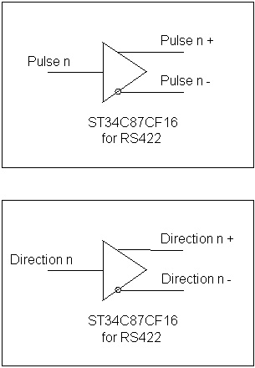

EQU outputs:
Those output are very fast (Signal delay time 50 nsec on controller side) switching at the actual encoder position.
View 2-20: EQU output driver | 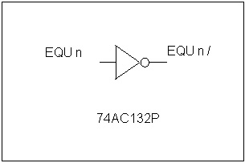
The electrical specs of the EQU outputs shows the following chart:
View 2-21: Electrical specification of the EQU output
  1- Signal voltage range | 0-2 V
  1-Signal current consumption | 5 mA
  0- Signal voltage range | 3-5 V or output open

The EQU outputs signal is 5V TTL,, so the user may have to design an interface circuitry.

Analog IO connector (ANA1)
This connector has the signals for 1 analog (0 -10V) input and optional 2 inputs (+/-10V) and 2 analog outputs, in detail the following:
- 1 input 0 to 10V 12bit
- 2 differential inputs (+/-10V) 12 bit, (optional)
- 2 differential analog outputs (+/10V), In a 5-Axes configuration the first one is used for the 5th servo axis. Otherwise as general-purpose output.
Name of the connector: ANA1
Position of the connector: See View 2 –24a and 2 -24b
Connector type: female, D-Sub 15
Cable cross section:
- Signal lines >=0.34mm2
- Power lines>=0.5mm2

Pin out of ANA1:
View 2-24 a:  Pin out of connector ANA1
  ANA1 (for units with S/N #3000 and later)
  Pin# | Symbol | Function | Description
  1 | ADCIN1 + | Input +/- 10V | Analog input 1 + (optional)
  2 | ADCIN1 - | Input +/- 10V | Analog input 1 - (optional)
  3 | ADCIN2 + | Input +/- 10V | Analog input 2 + (optional)
  4 | ADCIN2 - | Input +/- 10V | Analog input 2 - (optional)
  5 | ADCIN3 + | Input 0-10V | analog Input 3 +
  6 | ADCIN3 - | Input GND | Analog input 3 -
  7 | A+5V | Output | Digital Supply
  8 | NC |  | Not connected
  9 | DAC5+ | Output | Analog Out 5 +
  10 | DAC5- | Output | Analog Out 5 -
  11 | DAC6+ | Output | Analog Out 6 +
  12 | DAC6- | Output | Analog Out 6 -
  13 | ADCIN 4 + | Input 0-5V | ** see note1
  14 | ADCIN4 - | Input GND | ** see note1
  15 | AAGND | Output | Reference for ADC/DAC signals

** note1: in case of ADV400 with front panel (not Lite and not Pack), the analog input 4 is connected in parallel with the feed override potentiometer from the front. It’s recommended not to use the ADCIN 4 (pins 13 and 14) of this connector in this case.
View 2-24 b:  Pin out of connector ANA1
  ANA1 (for units with S/N up to #2150)
  Pin# | Symbol | Function | Description
  1 | ADCIN1 + | Input +/- 10V | Analog input 1 + (optional)
  2 | ADCIN1 - | Input +/- 10V | Analog input 1 - (optional)
  3 | ADCIN2 + | Input +/- 10V | Analog input 2 + (optional)
  4 | ADCIN2 - | Input +/- 10V | Analog input 2 - (optional)
  5 | ADCIN3 + | Input 0-10V | analog Input 3 +
  6 | ADCIN3 - | Input GND | Analog input 3 -
  7 | DIR_5+ | Output | Direction + Axis 5
  8 | PUL_5+ | Output | Pulse Output + Axis 5
  9 | DAC5+ | Output | Analog Out 5 +
  10 | DAC5- | Output | Analog Out 5 -
  11 | DAC6+ | Output | Analog Out 6 +
  12 | DAC6- | Output | Analog Out 6 -
  13 | NC |  | Not connected
  14 | NC |  | Not connected
  15 | AAGND | Output | Reference for ADC/DAC signals

Analog inputs:
The following block diagram shows the input circuitry principle of the analog inputs:
View 2-22: Schematic of analog inputs | 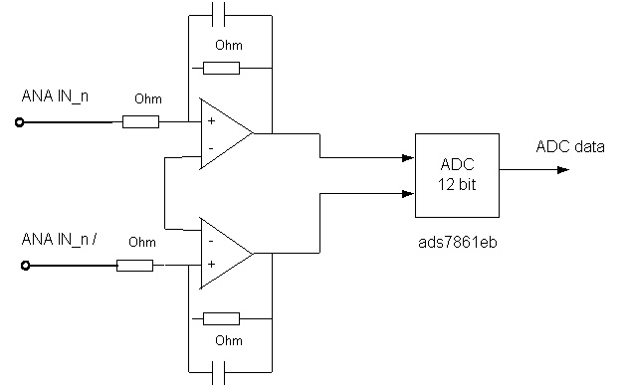

The electrical specs of the analog inputs shows the following chart:
View 2-23 Specs of the analog inputs
  Parameter |  | Units/ note
  Voltage range | -10-10 | V
  Resolution | 12 | Bits
  Conversion rate | Servo cycle | Default 442usec

Analog outputs
The following block diagram shows the circuitry of the analog outputs:
View 2-24: Output circuitry of the analog outputs

Outputs are referenced to pin15, „analog ground“

The electrical specs of the analog outputs shows the following chart:
View 2-25: Electrical specs of the analog outputs
  Parameter | Min | Max | Units
  Voltage range | - 10 | 10 | V
  Output current | -3 | 3 | mA
  Resolution | 12 bit

Digital input connector (IN1)
On this connector one can connect up to 32 optically isolated digital inputs. The inputs are grouped into 16 inputs.
Inputs 1-16 are referenced to pin36
Die inputs 17-32 are referenced to pin33
Name of the connector: IN1
Position of the connector: See View 2 -29
Connector type: male, D-Sub 37
Cable cross section:
- Signal lines >=0.34mm2
- Power lines>=0.75mm2
Pin out for IN1:
View 2-26: pin out for the digital inputs on IN1
  IN1
  Pin # | Symbol | Function | Description
  1 | INPUT1 | Input | Digital input 1, group 1
  2 | INPUT2 | Input | Digital input 2, group 1
  3 | INPUT3 | Input | Digital input 3, group 1
  4 | INPUT4 | Input | Digital input 4, group 1
  5 | INPUT5 | Input | Digital input 5, group 1
  6 | INPUT6 | Input | Digital input 6, group 1
  7 | INPUT7 | Input | Digital input 7, group 1
  8 | INPUT8 | Input | Digital input 8, group 1
  9 | INPUT9 | Input | Digital input 9, group 1
  10 | INPUT10 | Input | Digital input 10, group 1
  11 | INPUT11 | Input | Digital input11, group 1
  12 | INPUT12 | Input | Digital input 12, group 1
  13 | INPUT13 | Input | Digital input 13, group 1
  14 | INPUT14 | Input | Digital input 14, group 1
  15 | INPUT15 | Input | Digital input 15, group 1
  16 | INPUT16 | Input | Digital input 16, group 1
  17 | INPUT17 | Input | Digital input 1, group 2
  18 | INPUT18 | Input | Digital input 2, group 2
  19 | INPUT19 | Input | Digital input 3, group 2
  20 | INPUT20 | Input | Digital input 4, group 2
  21 | INPUT21 | Input | Digital input 5, group 2
  22 | INPUT22 | Input | Digital input 6, group 2
  23 | INPUT23 | Input | Digital input 7, group 2
  24 | INPUT24 | Input | Digital input 8, group 2
  25 | INPUT25 | Input | Digital input 9, group 2
  26 | INPUT26 | Input | Digital input 10, group 2
  27 | INPUT27 | Input | Digital input11, group 2
  28 | INPUT28 | Input | Digital input 12, group 2
  29 | INPUT29 | Input | Digital input 13, group 2
  30 | INPUT30 | Input | Digital input 14, group 2
  31 | INPUT31 | Input | Digital input 15, group 2
  32 | INPUT32 | Input | Digital input 16, group 2
  33 | I_RET2 | Input | Ref for group 2 inputs
  34 | NC |  | Not connected
  35 | NC |  | Not connected
  36 | I_RET1 | Input | Ref for group 1 inputs
  37 | Ext GND | Input | Ref for external field supply

The following block diagram in View 2-30 shows the input circuitry of the inputs:
View 2-27:Digital input block diagram | 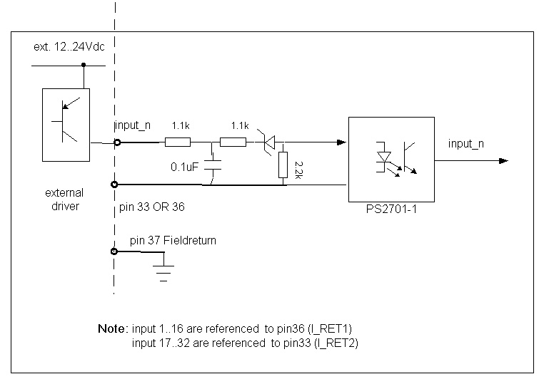
The electrical specs of the digital inputs are as follows:
View 2-28:  Electrical specs of the general digital inputs
  1- Signal voltage range | 11-30 V
  1-Signal current consumption | 5-20mA
  0- Signal voltage range | 0-  5 V or input open

Digital output connector (OUT1)
The connector gives the option to connect 16 digital general-purpose outputs.
Those outputs are optically isolated, can drive up to 0.5A and are grouped into 2 sets.
The following signals are found on OUT1:
- Digital outputs 1-8
- +24V for outputs 1-8
- Digital outputs 9-16
- +24V for outputs 9-16
- 2 field power return lines
Name of the connector: OUT1
Position of the connector: See View 2-32
Connector type: male, D-Sub 25
Cable cross section:
- Signal lines >=0.34mm2
- Power lines>=0.75mm2

Pin out of OUT1:
View 2-29: Pin out of the connector for the digital outputs (OUT1)
  OUT1
  Pin # | Symbol | Function | Description
  1 | OUTPUT1 | Output | Digital output 1
  2 | OUTPUT2 | Output | Digital output 2
  3 | OUTPUT3 | Output | Digital output 3
  4 | OUTPUT4 | Output | Digital output 4
  5 | OUTPUT5 | Output | Digital output 5
  6 | OUTPUT6 | Output | Digital output 6
  7 | OUTPUT7 | Output | Digital output 7
  8 | OUTPUT8 | Output | Digital output 8
  9 | Ext +24V | Input | External power supply 24VDC
  10 | Ext GND | Input | Ref, field return- ext. Power supply
  11 | NC |  | Not connected
  12 | NC |  | Not connected
  13 | NC |  | Not connected
  14 | NC |  | Not connected
  15 | NC |  | Not connected
  16 | OUTPUT9 | Output | Digital output 9
  17 | OUTPUT10 | Output | Digital output 10
  18 | OUTPUT11 | Output | Digital output 11
  19 | OUTPUT12 | Output | Digital output 12
  20 | OUTPUT13 | Output | Digital output 13
  21 | OUTPUT14 | Output | Digital output 14
  22 | OUTPUT15 | Output | Digital output 15
  23 | OUTPUT16 | Output | Digital output 16 * (see remark)
  24 | Ext +24V | Input | External +24V
  25 | Ext GND | Input | External field ground
 | *Output 16 is used as Drive enable in 5-Axis configuration

The following block diagram in View 2-33 shows the output circuitry:
View 2-30 Block diagram of the general digital outputs (OUT1) | 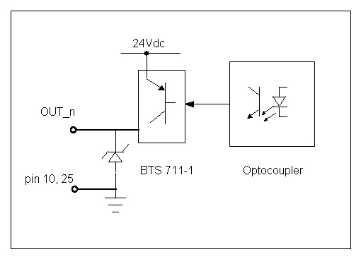
The electrical specs of the outputs shows the following chart:
View 2-31: Electrical specs of the general digital outputs OUT1
  1- Signal voltage range | Supply voltage
  1-Signal current consumption | Max 0.5 A, typical 5mA-0.3A
  0- Signal, max. Leakage current | 2mA

The power supply voltage can range between 12 and 24VDC. If all 16 outputs are powered by one power supply, the references of the 2 sets have to be connected to the supply reference. See also chapter .
for inductive loads, make sure that a quench diode in parallel to it.

MUX IO connector (XX1)
This IDC header for MUX IO gives the option to expand the digital IO capability of the controller. Usually Delta Tau’s MUX IO boards (like ACC.34 AA) are connected here.
Only use shielded twisted pair signal lines, put shield on conductive part of connector
Name of the connector: XX1
Position of the connector:
Connector type: IDC header, 26 pin

Power supplies
The ADV400 has to be supplied by at least 2 power supplies.
Besides the AC/DC- power supply to supply the internal logic power, a field power supply has to be connected to the machine peripheral.

Internal logic power supply
The internal AC/DC power supply is already integrated into the control box and only has to be connected to the following connector:
Name of the connector: AC POWER INPUT
Position of the connector: See View 2-35
The following block diagram shows the AC/DC interface:
View 2-32: Block diagram of the AC/DC interface | 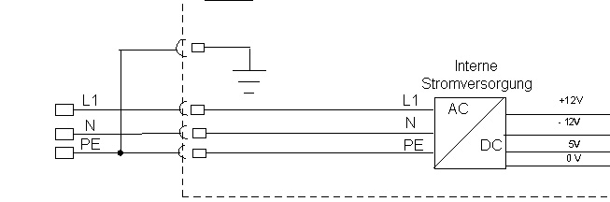

The electrical specs of the AC/DC power supply show the following chart:
View 2-33: Specs of the AC/DC power supply
  Parameter | Range | Unit
  Input voltage | 85-264 | VAC
  Nominal power | 40 | W
  Nom. Current consumption | 2 | Arms
  Inrush current | <18 | Arms

Field Voltage supply
External 12-24VDC has to be connected to maintain galvanic isolation between I/O’s and logic.

Communication interfaces

RS232
This port is to communicate direct with PMAC2104 from external PC, using Delta Tau’s terminal program family „PEWIN“
- Variables, parameter program download
- Uploads of parameters, programs for data backup
- Axis PID tuning
The serial cable should be shorter than 15m. The following cable pin out is suggested:

View 2-37: RS232 cable | 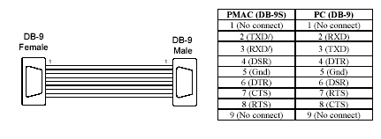
HINT
DTR and DTS are hardwired on the controller side. Those signals have to be connected for PEWIN ( PRO) communication.

USB interface
- Supported by Windows CE
- Use to connect keyboard, mouse, floppy, etc.
- Data exchange with controller

Ethernet (optional)
- Supported by Windows CE
- Data exchange with controller

Appendix 1: Hand Wheel box connection diagram

Connection diagram of the optional EDHW-B Hand Wheel box to ADV400.

